Emerging Software Engineering Principles

Project Sprint 2 Submission

John Foster, Clifton Malecki, Vladmir Maximov, Koko Afantchao

GitHub URL: <https://github.com/jtfoster2/Outdora>

Story Point Forecast: Sprint 1 was approximated to be 16 points of work across the team, and 14 was done between Cliff and John, other points from Koko and Vlad were pushed to the following sprint. We assumed 24 points because Krishna joined the team.

GitHub Projects Board URL: <https://github.com/users/jtfoster2/projects/1/views/1>

Tasking Proof: Stories are split into tasks using checkboxes in the issue description:

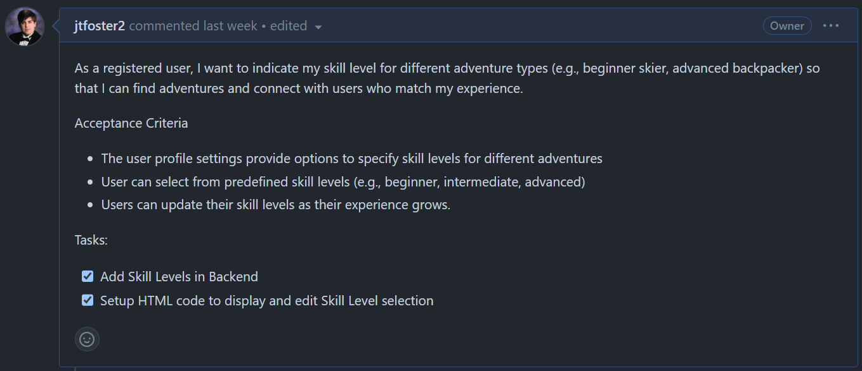

Sprint Burndown Chart: Implemented a Burndown Chart created by Joseph Hale: <https://github.com/thehale/github-projects-burndown-chart>

Pair Programming this Sprint: <https://kennesawedu-my.sharepoint.com/:v:/g/personal/jfost103_students_kennesaw_edu/EUIh1VORHh9FosCoKTRTzJoBlgdY3yTWKzPxLpRF4TNNsg?e=EPmzD2&nav=eyJyZWZlcnJhbEluZm8iOnsicmVmZXJyYWxBcHAiOiJTdHJlYW1XZWJBcHAiLCJyZWZlcnJhbFZpZXciOiJTaGFyZURpYWxvZy1MaW5rIiwicmVmZXJyYWxBcHBQbGF0Zm9ybSI6IldlYiIsInJlZmVycmFsTW9kZSI6InZpZXcifX0%3D>

Sprint Review: [ESEP - Team 2 - Silver Comets Standup-20240721_192107-Meeting Recording.mp4](https://kennesawedu-my.sharepoint.com/:v:/g/personal/jfost103_students_kennesaw_edu/Ec-xmI3yoStAhMjOVLrR4ScB_G-BqnOJccDq167bDb8lYA?e=MBjcMY&nav=eyJyZWZlcnJhbEluZm8iOnsicmVmZXJyYWxBcHAiOiJTdHJlYW1XZWJBcHAiLCJyZWZlcnJhbFZpZXciOiJTaGFyZURpYWxvZy1MaW5rIiwicmVmZXJyYWxBcHBQbGF0Zm9ybSI6IldlYiIsInJlZmVycmFsTW9kZSI6InZpZXcifX0%3D)

Release: Project is currently built into a docker image that can be run locally on localhost:8080, as an artifact in individual action runs: <https://github.com/jtfoster2/Outdora/actions>